**Date:** 8th JUN 2020

**Author**: Steve

**Version**: 1.1.0

**Tested on KSE 6.9 and Node 8.11.1 on Windows 10**

# Demo Description:

This demo aims to demonstrate the basic, Browse, Read, Write command.

The iotapp.js uses the HTTP Request to browse the IoT Server on Kepware. After which, we make use of use the data to form an array of tagnames for issuing the HTTP Post back to Kepware for a read operation.

Asynchronously, we write a unix timestamp back to Kepware.

# Pre-requisite:

* Install Nodejs: <https://nodejs.org/en/download/>
* npm install request: <https://www.npmjs.com/package/request>
* Internet Access

Note: In the sample, the module Kepware_iotgateway_function.js is located at a folder above the source codes for sharing. Change the require dir to ./Kepware_iotgateway_functions.js if using the module in the same folder.

# Pseudo Codes

# Set up Kepware

1. Load the provided sample file “GITDemo.opf”
2. Using the command prompt, navigate to the folder where the script it
3. Enter Npm install request to install the required module if you have not done so
4. Type node .\ Kepware_IoTFunction_demo.js

# Results from IoT Gateway

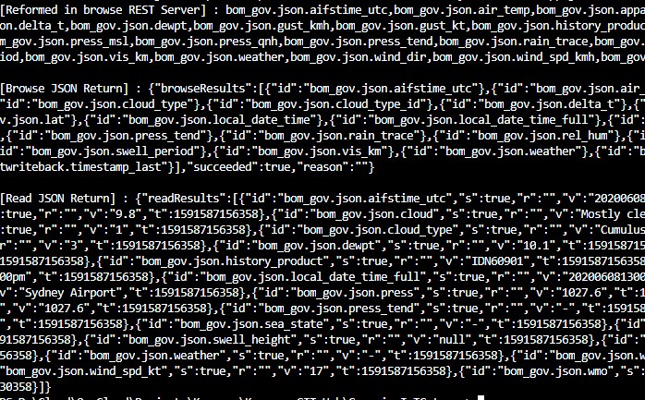

# Timestamp Writeback:

